# AstroSage Call Centre Data Analysis –

# Objective and Subjective Questions

**Prepared By:** Vishal Ratnakar  
**Date:** August 08, 2025

**Introduction:**

**This report presents key objective insights derived from AstroSage’s call centre dataset. The primary goal of this analysis is to identify operational patterns, service gaps, and customer behaviour trends to support data-driven decision-making following the recent funding received by AstroSage.**

**The analysis was conducted using Microsoft Excel with appropriate transformations, aggregations, and visual summaries to uncover answers to each objective question. This document serves as a foundation for deeper recommendations aimed at improving call centre efficiency, customer satisfaction, and business scalability.**

**Objective Questions:**

**Q1. What is the total number of tables present in the data?**

Based on the structure of the data received, the call centre data is maintained in a **single consolidated table.**

**Q2. What is the total number of columns present in the data?**

**The original dataset had 35 columns, and after cleaning and creating new derived columns, the final cleaned data contains 30 columns.**

**Q3. The data consists of some inconsistent and missing values, so ensure that the data used for further analysis is cleaned.**

**Removed Duplicates**

* **Checked for duplicate rows using key fields like user, guru, createdAT, and chatstatus.**
* **Removed redundant records to avoid skewed results during analysis.**
* **Sometimes the same session can be logged multiple times due to system errors or retries, so comparing user, guru, and timestamp together gives a more reliable check.**
* **The total rows consist of the raw data is 28027, after removing duplicates, the data consists of 28010 rows.**

**The process of removing duplicates:**

**Click on Data > Data cleanup > Remove duplicates**

**Dropped Unnecessary Columns**

* **Eliminated irrelevant technical or unused columns such as:**
  + **Queue, updatedAT, __v, statementEntryId,**
* **This helped simplify the dataset and improve focus on relevant metrics.**

**Standardized Date & Time Fields**

* **Extracted components from createdAT, such as:**
  + **Created_Date, created_Month, created_Year, and Created_Time, and added the Hours column.**
* **This allowed better time-based aggregation and trend analysis.**

**Verified & Corrected Data Types**

* **Ensured each column had the correct data type (e.g., dates in Date format, durations as Number, ratings as Number, etc.).**

**Restructured Columns**

**Columns in given dataset are spread and hard to understand, I structured them in a manner to easily readable and analysis.**

**Handling Missing Values**

* **Blank values in Chat or Call fields are not data issues — they reflect the nature of the session type and are safe to keep as-is. For better understanding I mentioned ‘user on chat’ in callChannel, callIvrType, CallSid, astrologerCallStatus and UserCallStatus columns.**

|  |
| --- |
|  |

**Q4. What is the change in daily call volume day by day and also find the average daily call volume?**

**Daily call volumes were calculated by creating Pivot, created_date into rows and CallSid in values field as count and filtering records with Consultation_Type = "Call".  
The call volume varied daily, with a peak of 430 calls on 10/12/2023 and a low of 107 calls on 03/01/2024.  
I observed that the daily number of calls varies significantly. I calculated this by subtracting the total number of calls on one day from the previous day's total.**

**The average daily call volume is approximately 249 calls per day.  
I found average by using =AVERAGE (RANGE OF DAILY CALLS) formula and used MAX and MIN function to found highest and lowest calls.**

**Created line chart for clear trend.**

**We can see there is uptrend in middle of the month.**

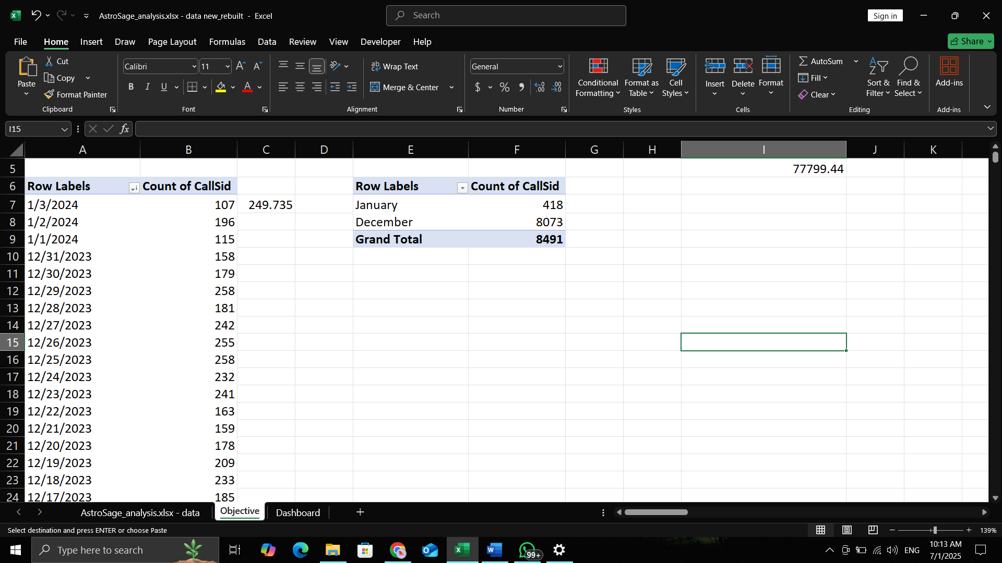

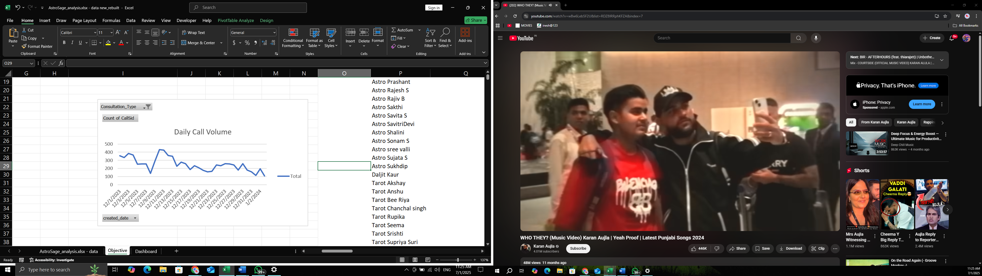

**Q5. Which months experienced the highest and lowest call volumes?**

**December 2023 had the highest call volume with 8073 calls, while January 2024 had the lowest with 418 calls.**

**I calculated the total number of monthly calls by grouping the data by month and taking the count of CallSid and filtering based on consultation_type.**

**I Created chart for visual representation.**

|  |  |
| --- | --- |
| **Row Labels** | **Count of CallSid** |
| January | 418 |
| December | 8073 |
| **Grand Total** | **8491** |
|  |  |

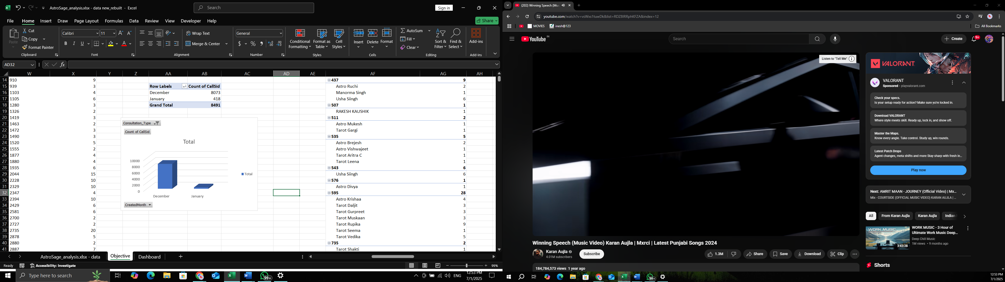

**Q6. What is the total operational cost for that month?**

The total operational cost for December **2023** is **₹99,146.57.**

**In the given dataset, there is only one column that indicates an expense to the company — the astrologer's amount. So, I considered the sum of the Astrologer_Amount column as the current operational cost. If additional expense data becomes available, the exact operational cost can be calculated by subtracting the total expense from the total revenue amount.**

**I have taken this sum by using Pivot or we can do it using SUM and SUMif functions.**

|  |
| --- |
| **Sum of astrologersEarnings** |
| 99146.57 |

**Q7. What is the average number of calls handled per agent per day?**

**Total Calls**: **8491**

Got this value by Pivot data count of callsid and filter this by consultation type.

**Number of days: 34**

Got this by count of unique created_date and I got value.

**Number of agents (Guru)- 148**

Function used: = COUNT of unique guru name

**First, we have to find the average number of calls per day.**

**Average number of calls per day =** Total calls / Number of days

= 8491 / 34

= 249.73

**Now find the average number of calls handled per agent per day.**

**Average number of calls handled by per agent per day** = Average number of calls per day / Number of agents

= 249.73 / 148

= 1.68

**So we can say that approx. 2 calls are handled per person per day.**

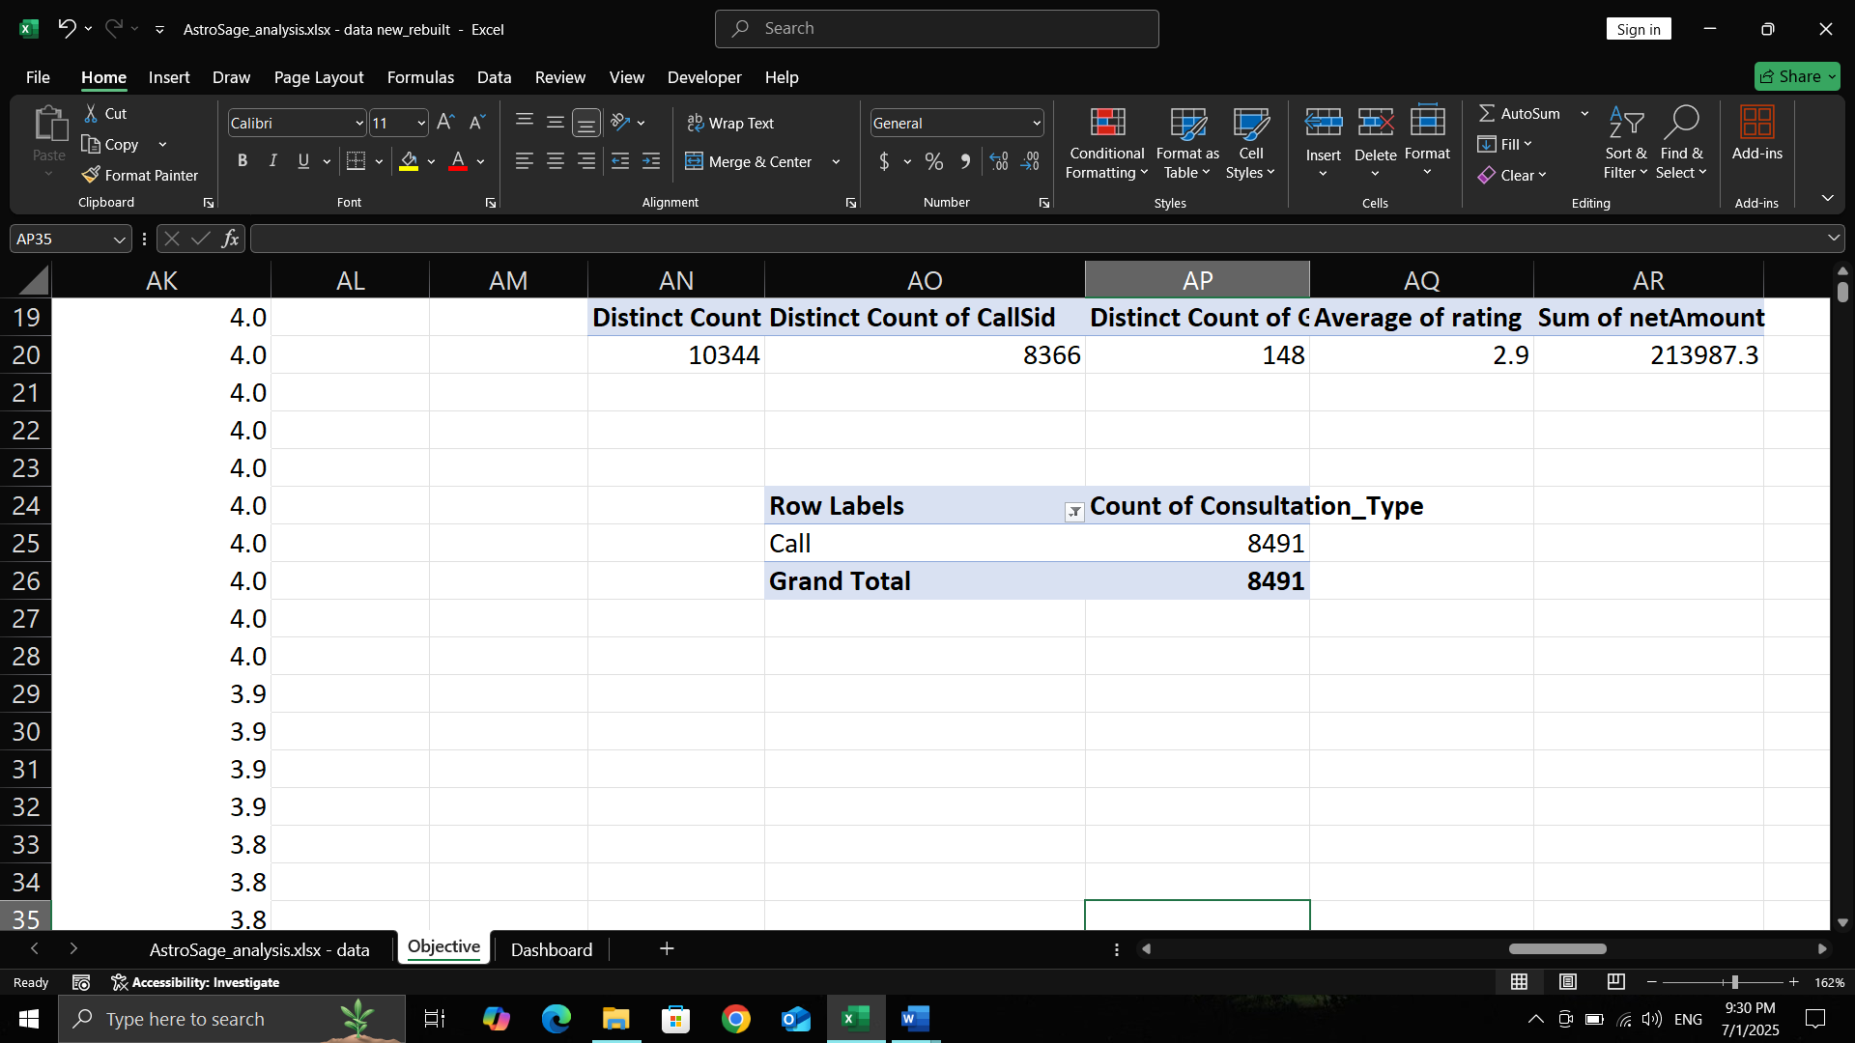

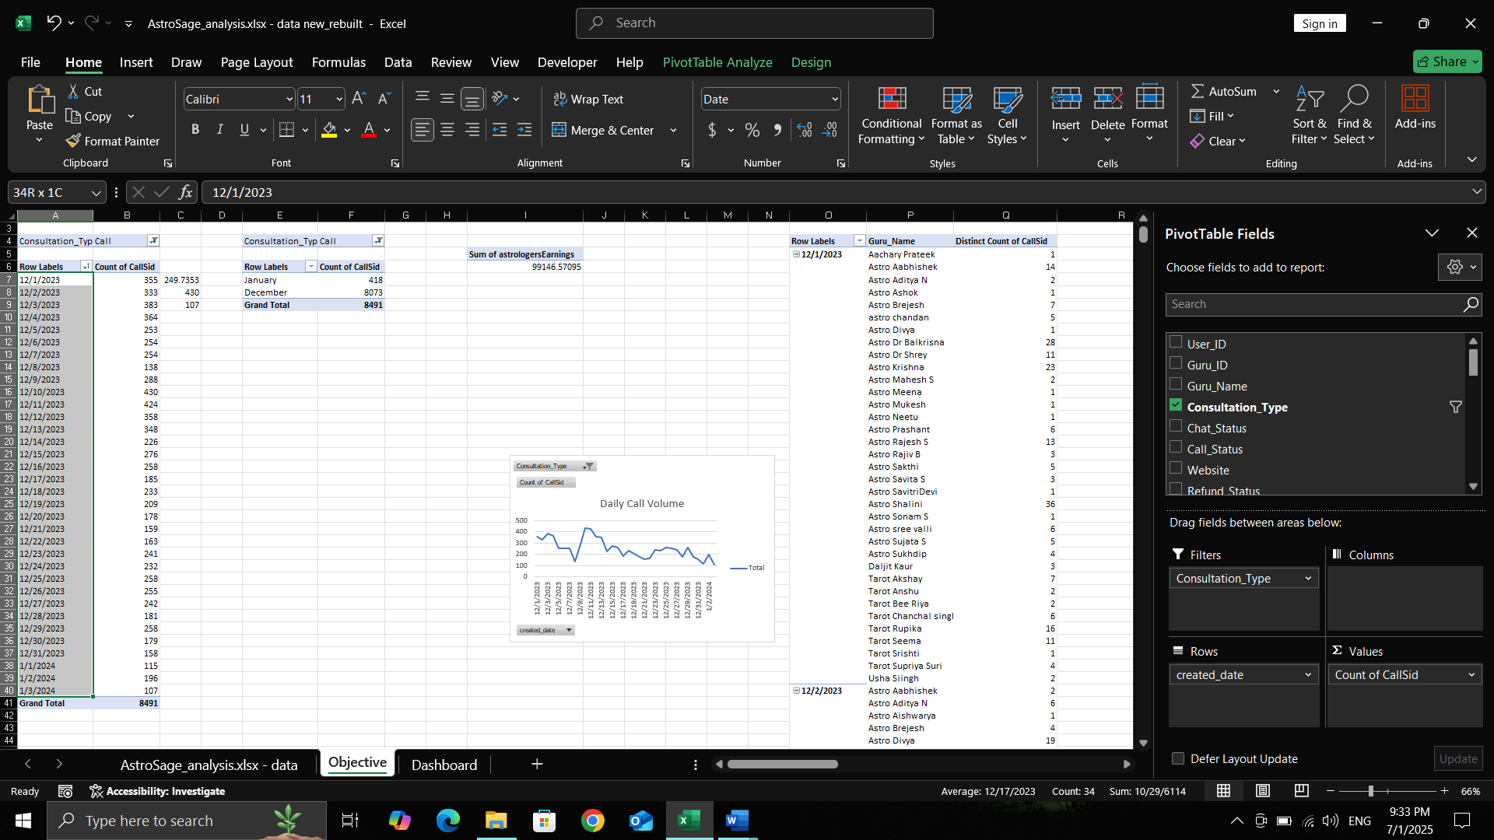

|  |
| --- |
| **Distinct Count of Guru_Name** |
| 148 |

**Q8. How many repeat callers are there, and what percentage of total calls do they represent?**

***To identify repeat callers, I created a Pivot Table by grouping the data based on User ID and used the count of CallSid in the values section. I also applied a filter for Consultation Type.***

***Step 1: Total Callers***

***First, I counted the total number of callers using the count of User ID:  
Formula: =COUNT(A8:A3636)  
This gave me 3,629 unique callers in the dataset.***

***Step 2: Single-Time Callers***

***Then, I calculated the number of users who called only once using COUNTIF, with the condition to count users who have exactly one call.  
Formula: =COUNTIF(B8:$B$3636,1)  
This gave a total of 2,352 users who called only once during the given period.***

***Step 3: Repeating Callers***

***Next, I calculated the number of repeat callers by using COUNTIF with the condition to count users who have made more than one call.  
Formula: =COUNTIF(B8:$B$3636,">1")  
I found there are 1,276 users who called more than once.***

**Total Calls (from all users):  
=SUM(B8:B3636)  
→ Result: 8,491 calls**

**Total Calls by Single-Time Users:  
=SUMIF(B8:B3636,1,B8:B3636)  
→ Result: 2,352 calls**

**Total Calls by Repeat Users (including their first call):  
=SUMIF(B8:B3636,">1",B8:B3636)  
→ Result: 6,139 calls**

**Actual Repeat Calls (excluding first call):  
=SUMIF(B8:B3636,">1",B8:B3636) - COUNTIF(B8:B3636,">1")  
→ 6139 - 1276 = 4,863 repeat calls**

***Finding the Percentages:***

***Repeated Calls (%):  
To calculate the percentage of total calls made by repeat callers:  
Formula: (Total calls by repeat callers / Total calls) * 100***

***(for finding total calls by repeated user and total calls I used sum and sumif formula)  
= (4863 / 8491) * 100 = 57.27%***

***So, 57.27% of the total calls were made by users who called more than once.***

***Repeated Callers (%):  
To calculate the percentage of repeat callers among total unique callers:  
Formula: (Repeat callers / Total callers) * 100   
= (1276 / 3629) * 100 = 35.16%***

***So, 35.16% of the callers are repeat users, and they contribute to 57.27% of the total calls.***

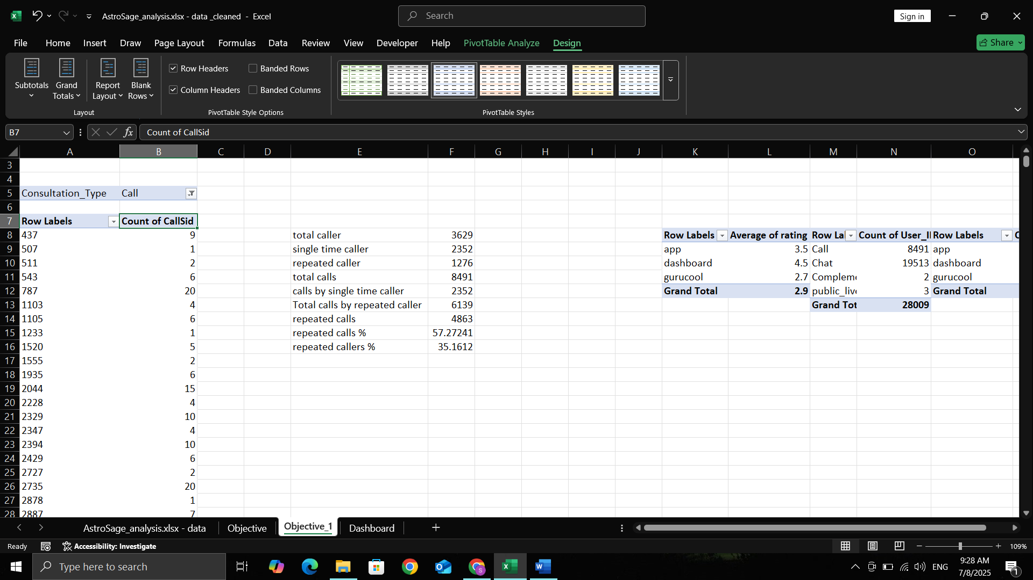

**Q9. What are the total sales generated by the call centre for each product category?**

The total sales generated by the call centre were calculated by grouping the data based on the consultation type. The dataset contains two main product categories: **Call** and **Chat**. I used a pivot table to sum the Amount column for each consultation type. As a result, the **Call category** generated total sales of **₹168442.04**, while the **Chat category** generated **₹45494.68**. These values represent the revenue collected from users for each type of service.

Revenue generated by calls is greater than by chats.

*(Reference: Pivot table screenshot attached)*

|  |  |
| --- | --- |
| **Row Labels** | **Sum of netAmount** |
| Call | 168442.04 |
| Chat | 45494.68 |
| **Grand Total** | **213936.72** |
|  |  |

**Q10. How many calls were made for each user ID and guru ID?**

To find how many calls were made for each user ID and guru ID, I filtered the dataset to include only rows where the Consultation_Type was "Call." Then, I created a pivot table using User_ID and Guru_Name as row fields and used the count of User_ID to represent the number of calls. This gave a clear mapping of how many times each user connected with each astrologer. The result highlights user preferences and astrologer engagement patterns.

*(Reference: Pivot table screenshot attached)*

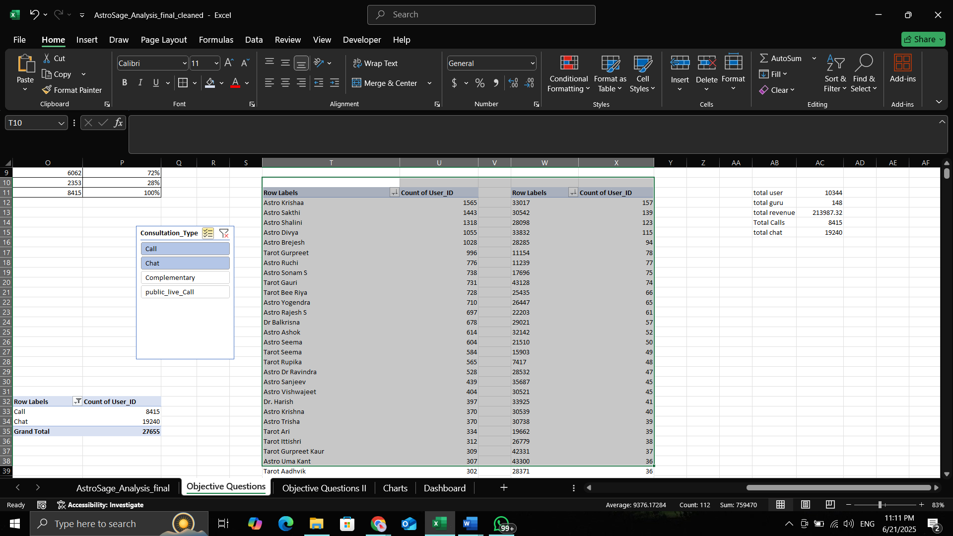

**Q11. What is the correlation between call duration and customer satisfaction?**

To measure the correlation between call duration and customer satisfaction, I first performed some data preprocessing. The consultation duration was originally recorded in seconds, so I converted it into minutes for better interpretation.

After cleaning columns, I used the

=CORREL('AstroSage_analysis.xlsx - data '!K:K,'AstroSage_analysis.xlsx - data '!AC:AC) in Excel to calculate the correlation coefficient between Consultation Minute and Rating. The resulting value was approximately **-0.0002**, indicating a **very weak negative correlation** between call duration and customer satisfaction.

This suggests that longer call durations do not necessarily lead to higher customer satisfaction, and in some cases, shorter, efficient calls might be preferred by users.

**Q12. Which guru has the highest and lowest customer satisfaction scores?**

To identify the gurus with the highest and lowest customer satisfaction scores, I created a pivot table using the Guru_Name column as rows and calculated the average of the Rating column. Before performing this analysis, Once the pivot was prepared, I sorted the average ratings in descending order, I accessed the **exact highest and lowest values** using the MAX and MIN functions on the average ratings. To fetch the corresponding guru names, I used INDEX and MATCH functions. The guru with the **highest average rating** was Astro Pujaa Rai and Tarot Mystical, and the guru with the **lowest average rating** was Tarot Rittika. This insight helps highlight the most and least appreciated astrologers based on user feedback.

*(Reference: Screenshot of pivot table with sorted average ratings attached)*

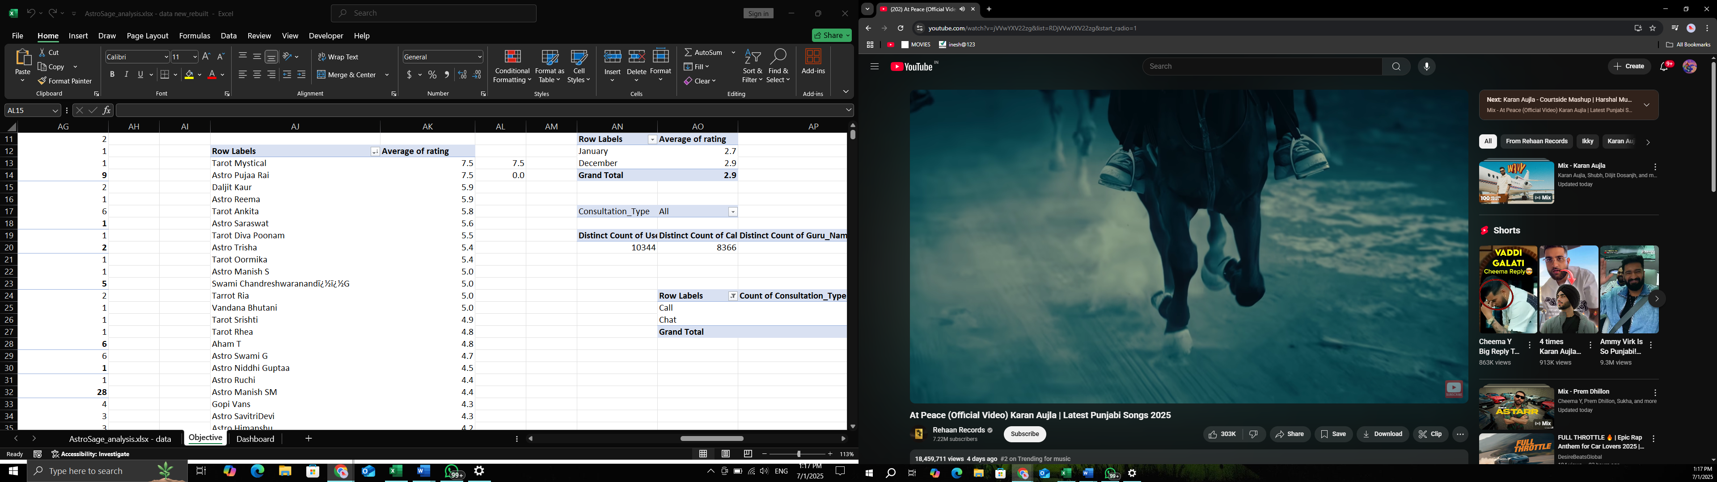

**Q13. What is the average customer satisfaction score by month?**

To calculate the average customer satisfaction score by month, I first extracted the month name from the CreatedAT column using the TEXT function in Excel. Then, I created a pivot table with Chat Month in the rows and Rating in the values section, set to average. This gave me the average customer satisfaction for each month. The analysis showed that the average customer satisfaction score was **2.9 in December** and **2.7 in January**, indicating very similar satisfaction levels across both months.

*(Reference: Pivot table and formula screenshots attached)*

|  |  |
| --- | --- |
| **Row Labels** | **Average of rating** |
| January | 2.7 |
| December | 2.9 |
| **Grand Total** | **2.9** |

**Q14. How many categorical columns are there in the data?**

Categorical Columns (Qualitative):

1. chatStatus
2. guru
3. guruName
4. gid
5. uid
6. consultationType
7. website
8. refundStatus
9. isWhiteListUser
10. freeCall
11. freeChat
12. callChannel
13. callIvrType
14. callStatus
15. region
16. userCallStatus
17. created_month (extracted)
18. created_year (extracted)
19. created_time (optional, if binned or grouped)
20. Hour ( extracted, we can use this for grouping by hour of the day)

**Total Categorical Columns = 20**

Continuous Columns (Quantitative):

1. chatSeconds
2. userOnCallDuration
3. astrologerOnCallDuration
4. astrologersEarnings
5. amount
6. netAmount
7. rating

**Total Continuous Columns = 7**

**Subjective Questions:**

**Question 1: Should the investment be used to hire more agents, improve training programs, or upgrade call centre technology?**

**1) Hiring More Agents**

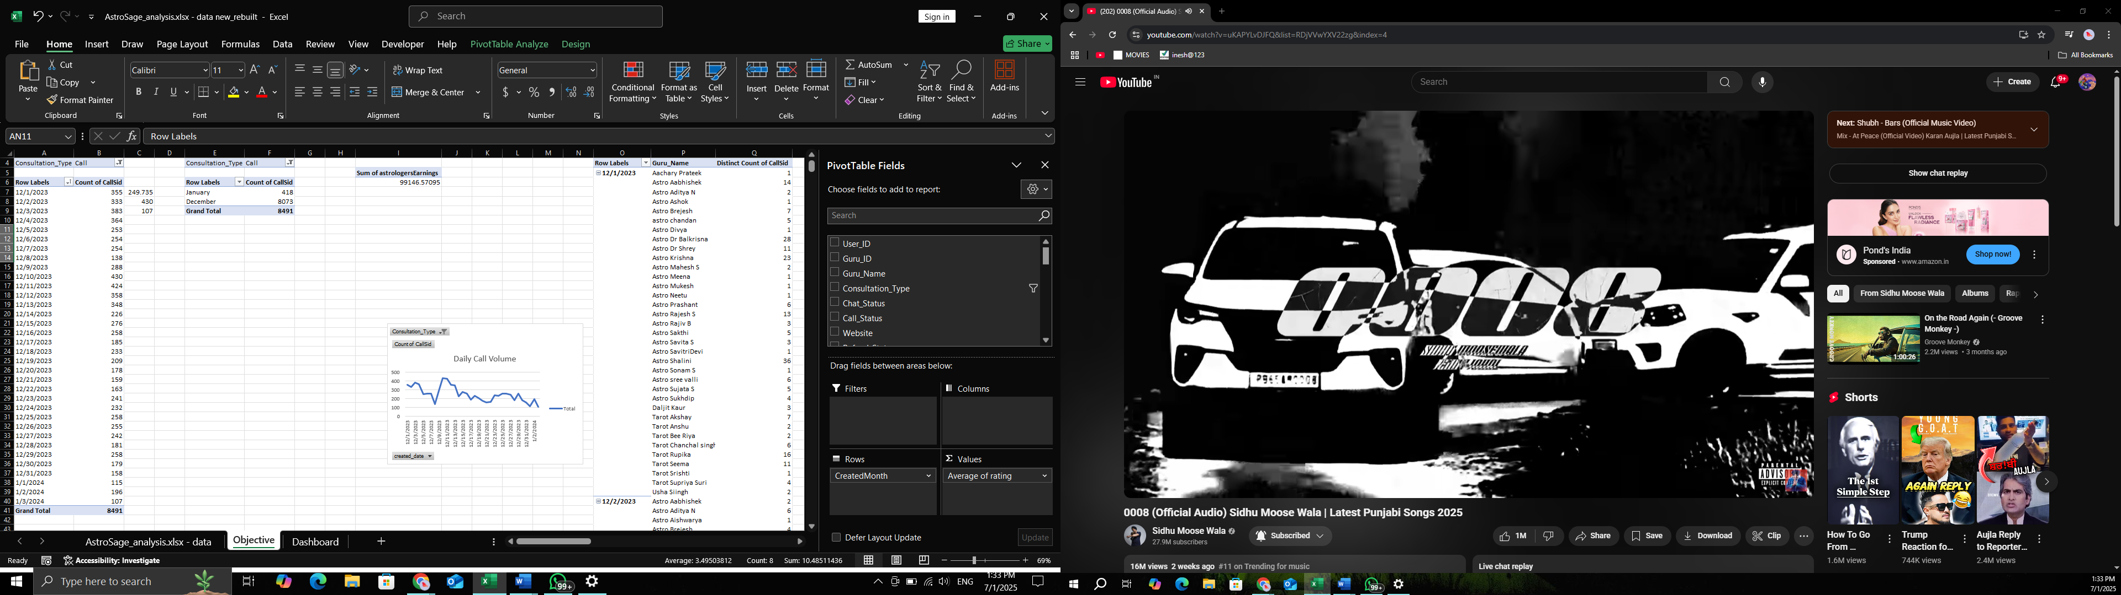

**Average number of calls per day = 250 (Formula : =AVERAGE())**

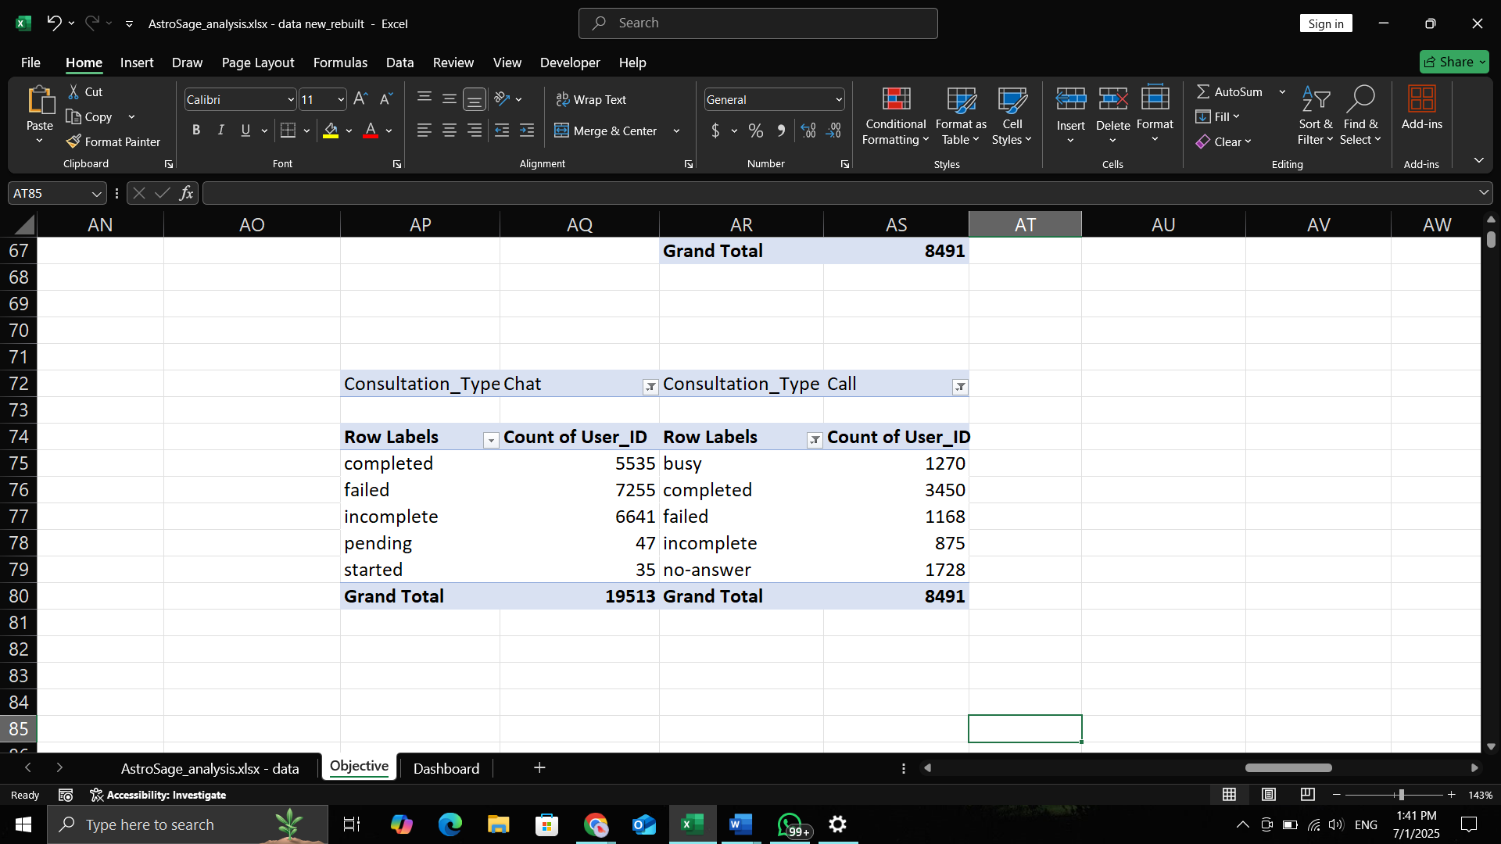

**% of calls gets complete = 40.63 % {Formula= (Completed calls * 100)/ total calls}**

**The call center receives approximately 250 calls per day, but only 40.63% of calls are completed. To manage the workload, investment is needed in hiring agents.**

**2) Improve training programs**

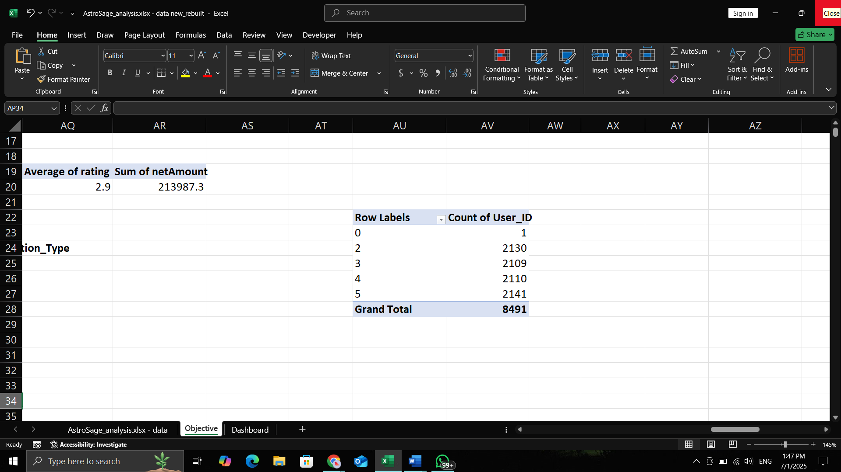

**Only 25.21% of users are satisfied with the service.**

**Total users = 20694**

**Satisfied user (Rating-5,6,7,8) = 37.13 %**

**(formula- =(SUM(satisfied users)*100/total users))**

**Unsatisfied user (Rating-1,2,3,4) = 74.79 %**

**I think the investment should be used to improve the training program.**

**3) Upgrade call center technology**

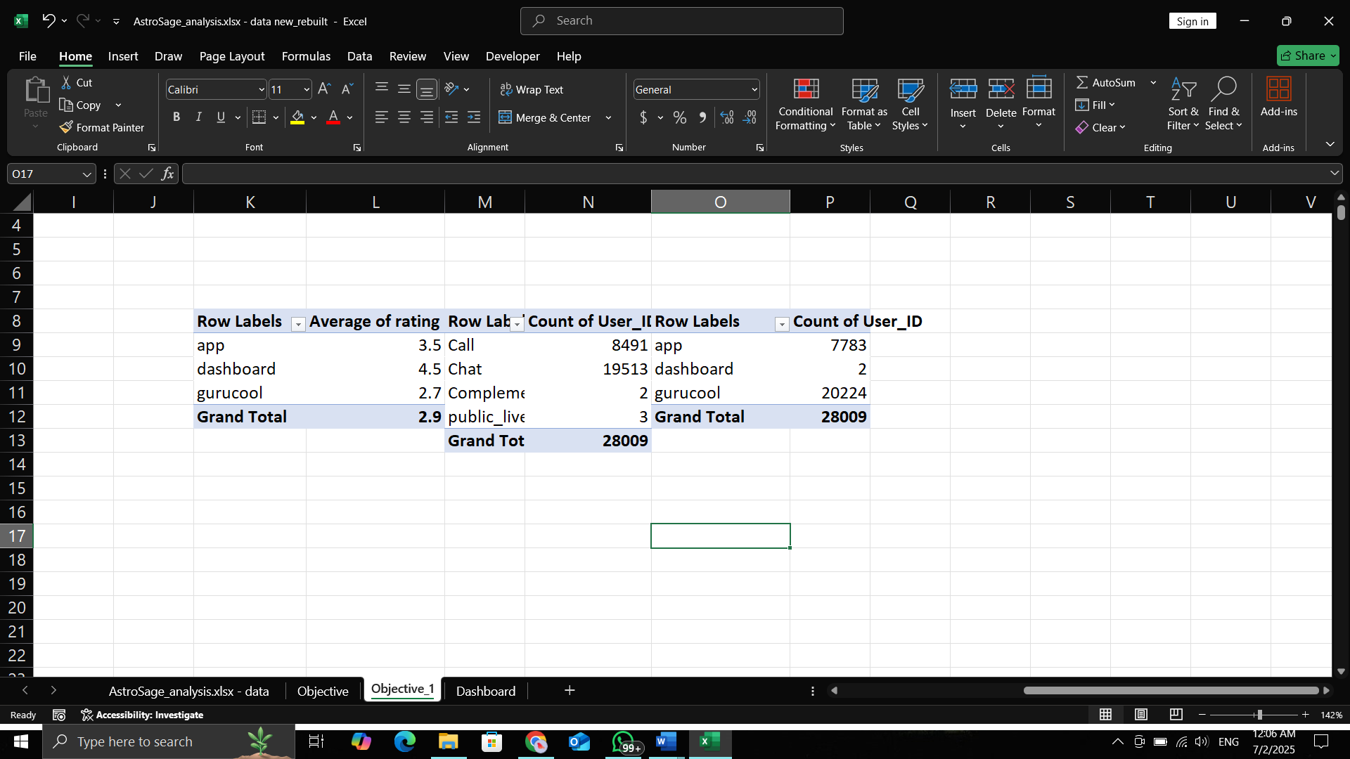

**69.8% of users use the chat service, primarily through the Gurucool platform, which has an average rating of just 2.72, indicating significant user dissatisfaction. This highlights a clear need for technology upgrades to improve service quality, user experience, and retention. Investing in tech will enhance system performance and satisfaction, though potential risks like implementation delays and training requirements should be planned for and mitigated.**

**Question 2: What are the potential risks of each investment option (hiring, training, technology upgrades), and how can they be mitigated?**

**Name the chart/spreadsheet function you will use for solving the problem.**

**1) HIRING**

**Possible Problems (Risks):**

1. High hiring cost – The company has to spend money on hiring, like paying agencies or job platforms.
2. Training cost wasted – If the new employee doesn’t perform well, the time and money spent on training them goes to waste.
3. Leaves quickly – If the person doesn’t stay long, it wastes company time and effort.
4. Wrong skills – If the person hired doesn’t have the right skills, it may lead to poor work or delays.
5. Bad behavior – If the new hire behaves badly or unprofessionally, it can affect the company’s image.

**Mitigating These Problems (Solutions):**

1. Take more interview rounds to better check their skills and behavior.
2. Clearly explain the job role and expectations before hiring.
3. Check if they match the company culture to make sure they’ll stay longer.

**2) TRAINING**

Only 37.13% of users are satisfied with the service.

**Total users = 20694**

**Satisfied user (Rating-5,6,7,8) = 37.13 %**

(formula- =(SUM(satisfied users)*100/total users))

**Unsatisfied user (Rating-1,2,3,4) = 62.87 %**

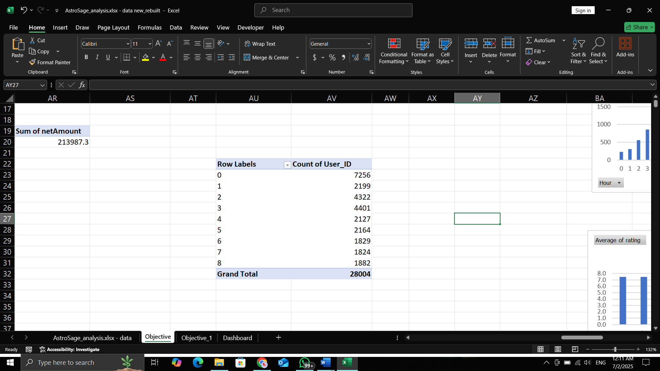

**Possible Problems (Risks):**

1. High cost – Hiring outside trainers or giving paid certifications can be expensive.
2. Employees may leave – After learning new skills, some employees may switch jobs for better offers.
3. Training may not help – If the training is not related to the actual work, it won’t improve performance.

**Mitigating These Problems (Solutions):**

1. Use in-house training where possible, and check if the cost is worth the results.
2. Build a positive work environment and give chances to grow within the company.
3. Use contracts or agreements so employees stay for some time after training.

**3) TECHNOLOGY UPGRADES:**



69.7% of users use the chat service, primarily through the Gurucool platform, which has an average rating of just 2.72, indicating significant user dissatisfaction. This highlights a clear need for technology upgrades to improve service quality, user experience, and retention. Investing in tech will enhance system performance and satisfaction, though potential risks like implementation delays and training requirements should be planned for and mitigated.

Possible Problems (Risks):

1. High cost – Upgrading systems can be expensive. It includes buying software, licenses, hardware, and training.
2. Need for training – Employees may need help learning how to use the new systems.
3. May not work as expected – The new tools might not perform well or might need more resources (like faster internet or better devices).
4. Risk of losing data – Data might get lost or corrupted during the upgrade.

How to Reduce These Problems (Solutions):

1. Make a clear budget plan before starting the upgrade to avoid overspending.
2. Train employees properly so they can use the new tools with confidence.
3. Back up all important data before making any changes, so nothing is lost.

**Question 3: How does AstroSage's call center performance compare to AstroGuru's average call volume, customer satisfaction, and agent performance? Will you use any aggregation function or a visualization here to solve the problem?**

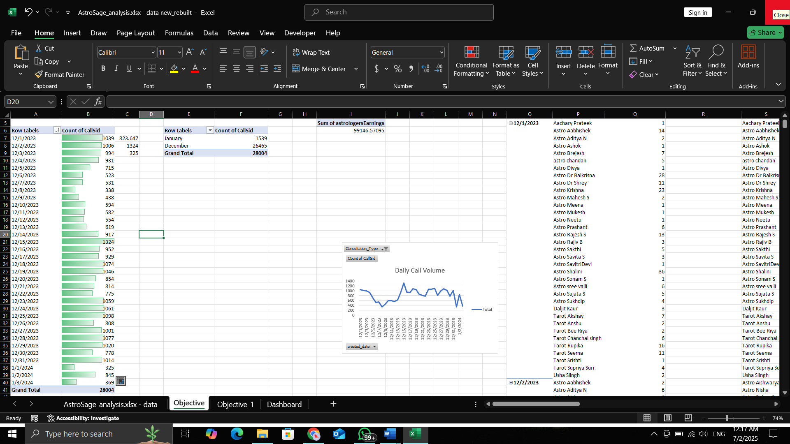

The call center receives around **250 calls per day**, and there are **148 gurus available** to handle them.

However, out of **8,491 total calls**, only **3,450 were completed**, which is just **40.63%**.

This means **59.36% of users didn’t get their call session**, even after booking it.

This low completion rate is one of the main reasons why the **average rating for the call service is only 3.5**.

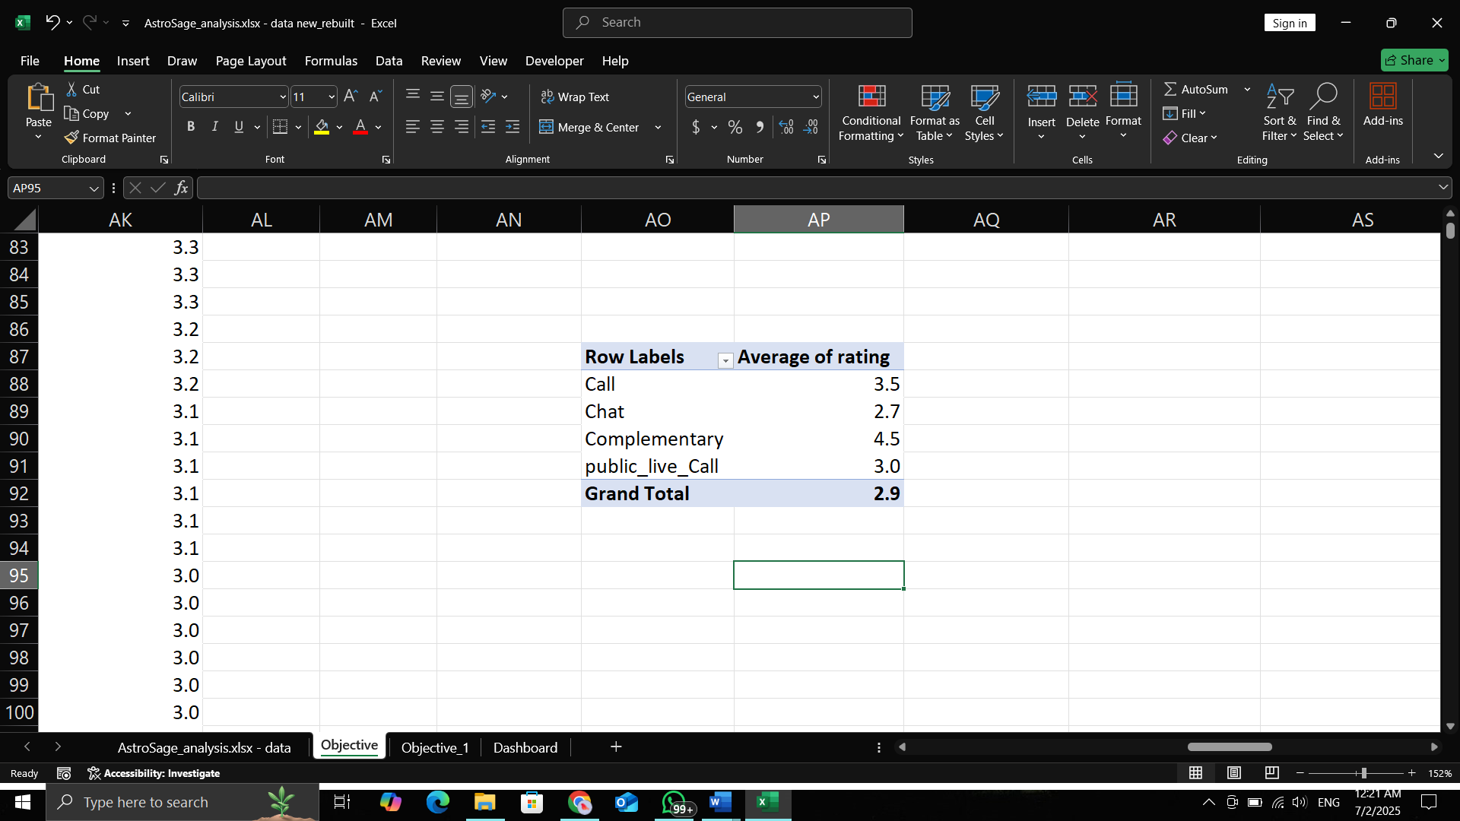

If astrologers’ **ratings improve**, the overall **company rating will also improve**.

Since **78.71% of the company's net income** and **78.46% of astrologers’ earnings** come from the **Call service**, it's clearly the key revenue source.

So, **investing in training programs** to improve astrologer performance would be a **smart and strategic move** to maintain and grow this success.

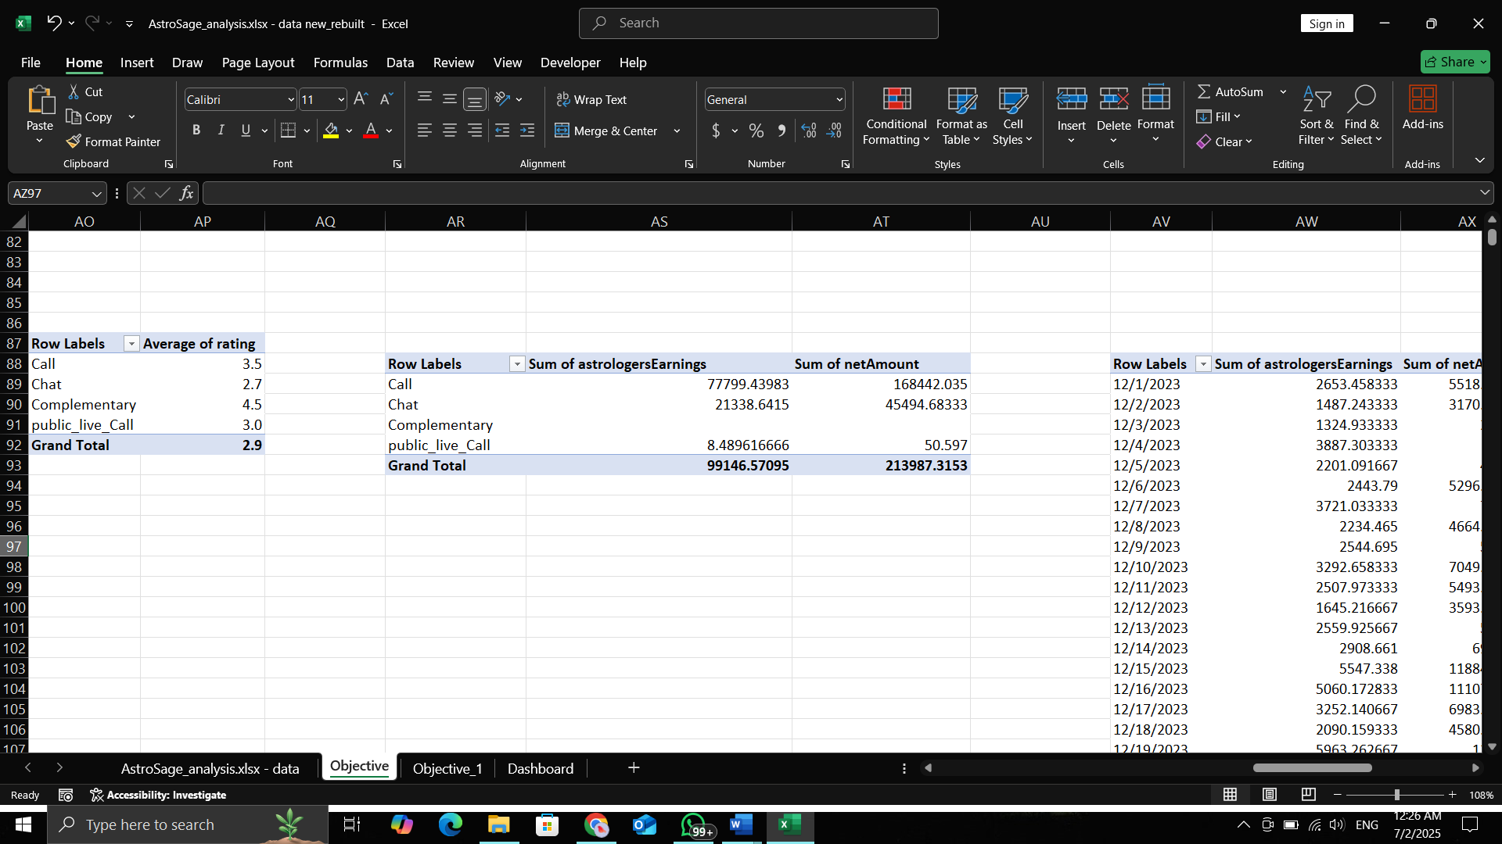

Percent of call income = (Call income * 100)/Total income

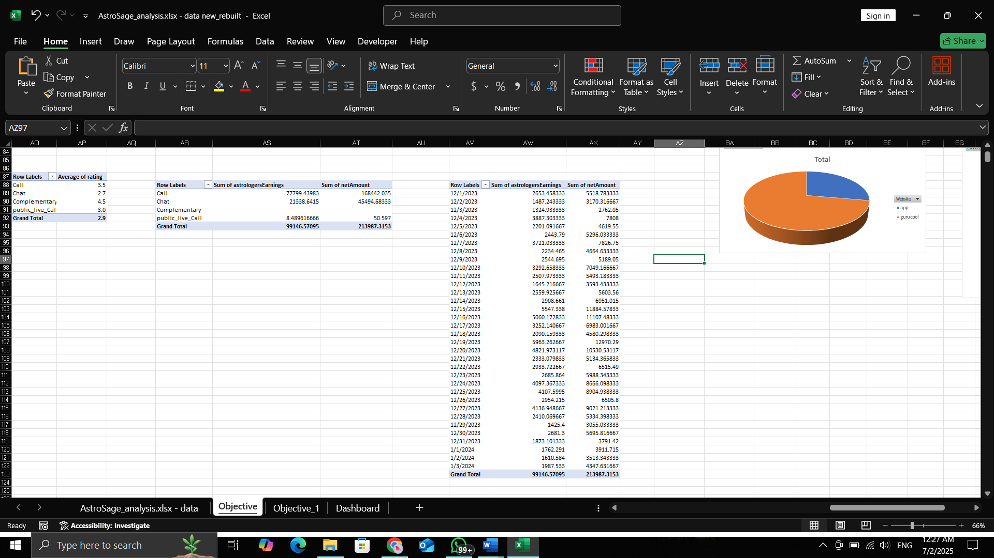

The performance of agents (astrologers) is crucial to the company’s success because their earnings are strongly linked to the company’s income.

Using the formula “=CORREL()”, the correlation between astrologers’ earnings and the company’s net income is 0.9969, which shows a very strong positive relationship.

This means:  
When agent earnings increase, the company’s net income also increases-almost every time and in a predictable way.  
A correlation of 0.99 indicates that both are highly interconnected, and improving agent performance can directly boost company profitability.

**Question 4: How can the call center improve its handling of peak call periods to ensure high customer satisfaction? Mention the functionality you will use for giving the suggestions — will it be any aggregated function or a visualization?**



On **December 10 and 11, 2023**, the call center received the **highest number of calls**.

However, only **34.82% of users were successfully served**, while the remaining **65.18%** received messages such as **"astrologer busy"** or had their **calls cancelled** due to the unavailability of astrologers.

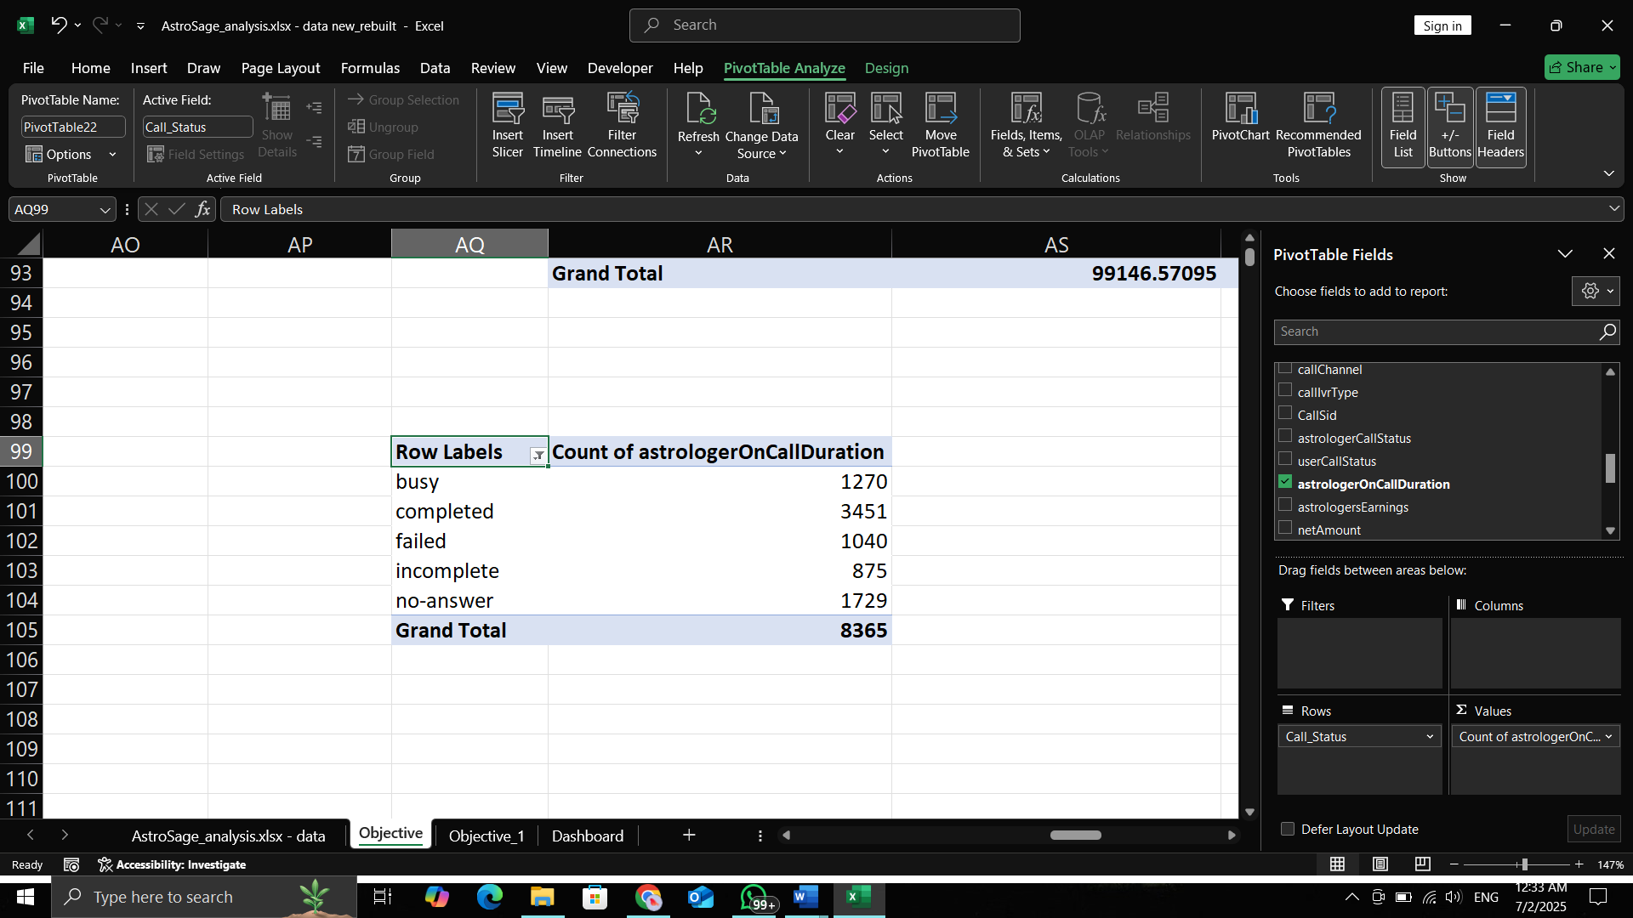

**Completed call % = (Completed calls * 100)/ total calls**

**Analysis of peak hours -**

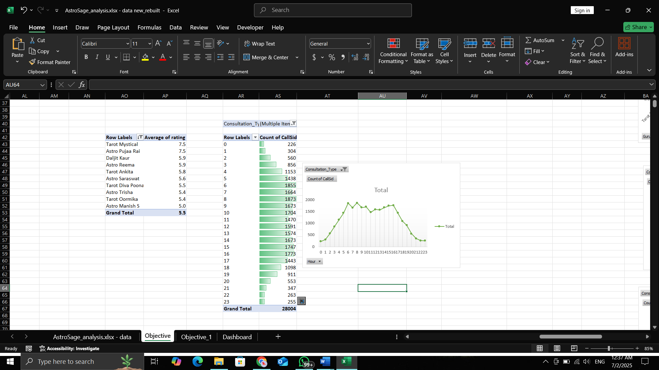

Here we can see the hourly distribution of calls. First, we have to take out hours from creation time with the help of = HOUR FUNCTION, later by taking hours in a row, the count of calls in values, and consultation type in filters, and set that filter as call. This is how we can form the pivot table, and later with the help of the pivot table, we can visualize it witha chart.

* **Introduce Live Streaming:**

The company can offer live sessions where astrologers interact with multiple users at once. This will reduce waiting time, keep users engaged, and also help generate more revenue.

* **Optimize Agent Shifts:**  
  Schedule more agents during peak hours (like evenings or weekends) to handle higher call volumes efficiently.
* **Hire Part-time or Freelance Agents:**Keep a few on-call or freelance astrologers who can step in during busy times.

This helps manage the load without adding permanent staffing costs.

**Question 5: Based on historical data, what strategic initiatives should be prioritized to improve efficiency and customer satisfaction?**

**STRATEGY 1- Training programs**

Only 37.13% of users are satisfied with the service.

**Total users = 20694**

**Satisfied user (Rating-5,6,7,8) = 37.13 %**

(formula- =(SUM(satisfied users)*100/total users))

**Unsatisfied user (Rating-1,2,3,4) = 62.87 %**



**Agent Training & Quality Improvement**

* Strong correlation (0.9969) between agent earnings and company profit shows that agent performance directly impacts business.
* Conduct regular training to boost astrologer skills, which in turn improves user ratings and retention.

**STRATEGY 2 – Upgrade Technology.**



**Upgrade Technology**

* With **69.62%** of users using the **chat service** and an average rating of only **2.72** (for Gurucool), there is a clear **need to enhance the chat platform** for a smoother user experience.

**STRATEGY 3 – Optimize Staffing During Peak Hours**



* On peak days like 2023-12-10 & 2023-12-11, only 34.82% of users got service.
* Use shift planning, part-time astrologers, or live sessions to better handle high traffic.

**This move can make the company stand separate among the rivals. And bring customers and revenue to the company.**

**Question 6: What can be the key factors contributing to high customer satisfaction scores, and how can these be leveraged to improve overall performance? What is the basis for the suggestions? And mention how you decided if the satisfaction score affects the ratings.**

**69.80% of total users use the chat service.**

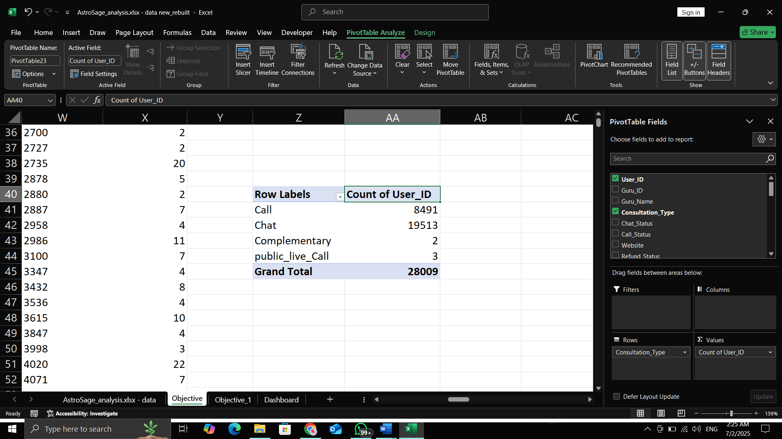

**% of user using chat = (Chat user*100)/ Total user**

**Rating of 6,7,8 is considered as the high satisfaction range.**

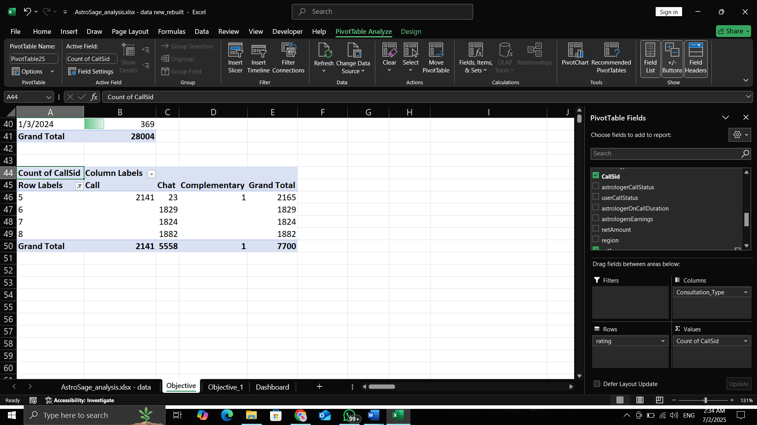

**Only chat service receives the rating of 6,7,8.**

**As 69.80% of total users use the chat service and 100% of high satisfaction scores is given by chat user only, then the Chat service can be considered as the key factor contributing to high satisfaction score.**

**Improvements:**

**To further enhance user experience, the company can:**

* **Introduce AI chatbots to handle basic queries and reduce wait times.**
* **Train employees to adopt new tools, technologies, and workflows that support better service delivery.**

**These steps will help the company boost overall performance and user satisfaction.**

**Question 7: How should the call center balance the workload among agents to ensure optimal performance and avoid burnout?** Mention your approach and spreadsheet function for the answer.



**Average number of calls per day = 250** (Formula : =AVERAGE())



**% of calls gets complete = 40.77 %** {Formula= (Completed calls * 100)/ total calls}

Call centre receives approx. 250 calls per day, but only 40.77% of calls are completed in total from the astrologer's side.

**Suggestions-**

1) To balance the workload company can analyze the historical data. The hourly distribution of calls can help the company to balance workload accordingly among agents.



2) Introduce live streaming to handle multiple users at once and increase engagement.

3) Optimize agent shifts by scheduling more agents during peak hours.

4) Use part-time or freelance astrologers to manage high workloads cost-effectively.

5) Implement AI chatbots to handle basic queries and reduce agent load.

6) Analyze hourly call trends to distribute workload more evenly among agents.

Question 8: What new technologies or tools could be implemented to enhance call centre operations and customer service?

* AI Chatbots  
  Handle basic user queries 24/7, reduce agent workload, and improve response speed.
* Live Streaming Sessions  
  Allow astrologers to interact with multiple users at once, especially during peak times.
* Call Routing Systems  
  Automatically direct users to the best available astrologer, reducing wait and call drop rates.
* Real-time Dashboards & Alerts  
  Monitor agent performance, call traffic, and satisfaction in real time for quick decision-making.
* Automated Feedback Collection Tools  
  Collect post-session ratings and suggestions without manual effort.

**Question 9: What metrics should be included in the final dashboard to comprehensively view call center performance and guide investment decisions?**

To effectively monitor call center performance and support strategic investment decisions, I added mixed of **operational, financial, and quality-focused metrics**.

Key metrics to include:

1. **Total Calls & Chats Handled** – Tracks overall workload and service type preference.
2. **Total users** – Helps assess efficiency and workload per consultation.
3. **Customer Satisfaction Score (Average Rating)** – Measures quality of service and user feedback.
4. **Total Guru** – For getting view on available work force.
5. **Revenue by Consultation Type (Call vs. Chat)** – Guides which service drives profitability.
6. **Agent-wise Performance** – Includes total calls handled, average rating, and workload balance.
7. **Peak Hour/Day Trends** – Identifies when to allocate more resources.
8. **Daily Call Volume** – for getting daily performance and workload management.
9. **Revenue by consultation type** – for identifying which service is generating what percentage of total revenue.
10. **Monthly average rating** – for tracking customer satisfaction for quick actions
11. **Ca**ll status – for identifying call status
12. Consultation type – for identifying which products are mostly used by the users for better customer satisfaction and service
13. Top 10 guru – for identifying which agents are mostly liked by the users so we can analyse there common practice and can provide same training to other agents for better customer satisfaction and this data can help us to recognise those agents who are successfully satisfying customers.

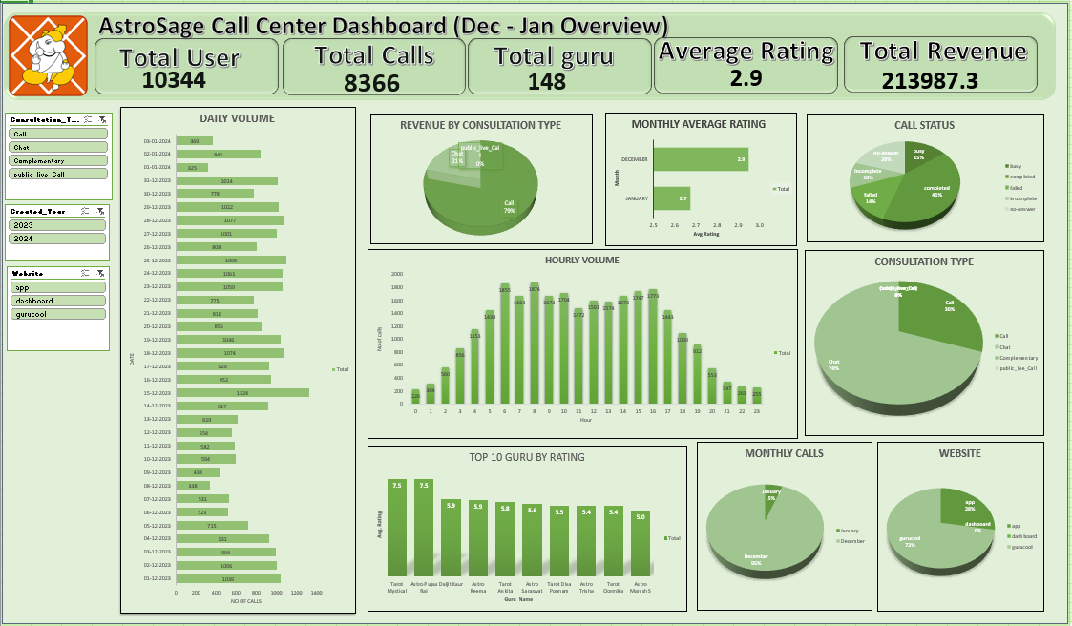**Question 10: How would you allocate a 1 crore rupee investment to optimize operational efficiency, enhance customer satisfaction, and boost profitability, and what analysis-based recommendations would you offer to support this?**

**1. Technology Upgrade – ₹40 lakhs (40%)**

* 69.62% of users use chat services, mainly on Gurucool, which has a low average rating of 2.72.
* Recommendation:

Upgrade the chat platform (UI/UX).

Introduce AI chatbots for instant query resolution.

Improve backend performance to reduce lag or crashes.

* Expected Outcome: Improved chat satisfaction, better retention, and reduced operational delays.

**2. Agent Training Program – ₹25 lakhs (25%)**

* Only 40.77% of booked calls are completed. Calls are the main revenue driver, contributing 78.69% of the company’s income.
* Recommendation:
  + Conduct monthly training on soft skills, upselling, and technical handling.
  + Use analytics to identify underperforming agents and offer targeted coaching.
* Expected Outcome: Increase in successful calls, better customer experience, and improved satisfaction.

**3. Support Infrastructure, Data Security & Customer Care Tools – ₹35 Lakhs (35%)**

* Hire freelance/part-time agents to manage peak hours and reduce customer wait time.
* Invest in infrastructure and data protection (cloud backups, system stability).
* Set up automated feedback tools (post-call surveys, follow-ups) to improve customer support and satisfaction.

### **Conclusion**

This project offered a valuable opportunity to apply data analytics to solve real business challenges faced by AstroSage’s call center operations. Through detailed data cleaning, exploratory analysis, metric building, and dashboard planning, I was able to uncover meaningful patterns and provide actionable recommendations focused on operational efficiency, customer satisfaction, and strategic investment planning.

The insights and suggestions presented in this report are based entirely on thorough analysis of the dataset provided. I have ensured that each recommendation is data-driven, practical, and aligned with industry best practices. I believe that with the implementation of these insights, AstroSage can strengthen its service delivery, retain more customers, and scale its operations efficiently.

Thank you for reviewing my work.

**– Vishal Ratnakar**  
(Excel | SQL | Power BI | Python)